
S9500-6QF-2HQF，100G核心交换机
- 产品概述
S9500-6QF-2HQF交换机是公司一款高性能高速率产品，支持40G下行和100G上行核心路由三层交换机产品。既可满足下一代企业网、数据中心和城域网对于高密度高带宽的网络 应用需求，也可满足电信网络运营商或园区以太网汇聚层或接入层应用需求，亦可作为数据 中心接入层、中小企业核心层，为数据中心提供丰富的服务器接入方案。

- 产品外观
S9500-6QF-2HQF  6*40G QSFP端口  2*100G QSFP28 端口 | 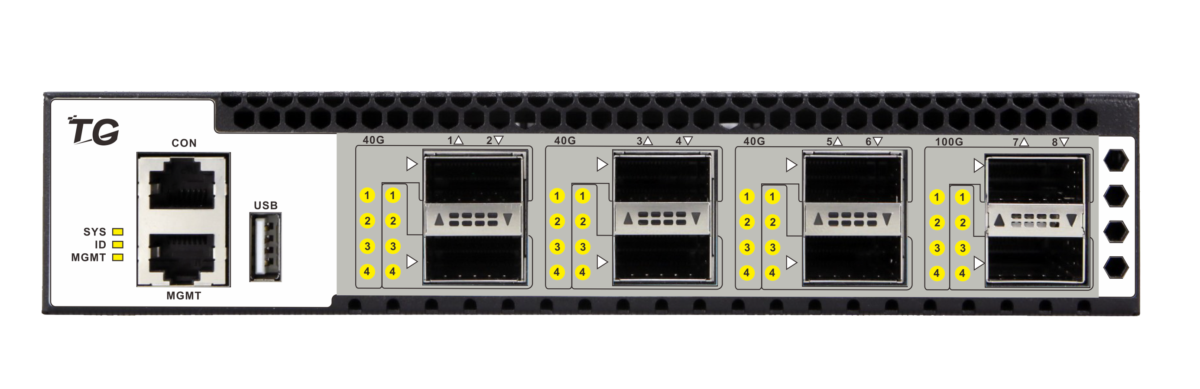
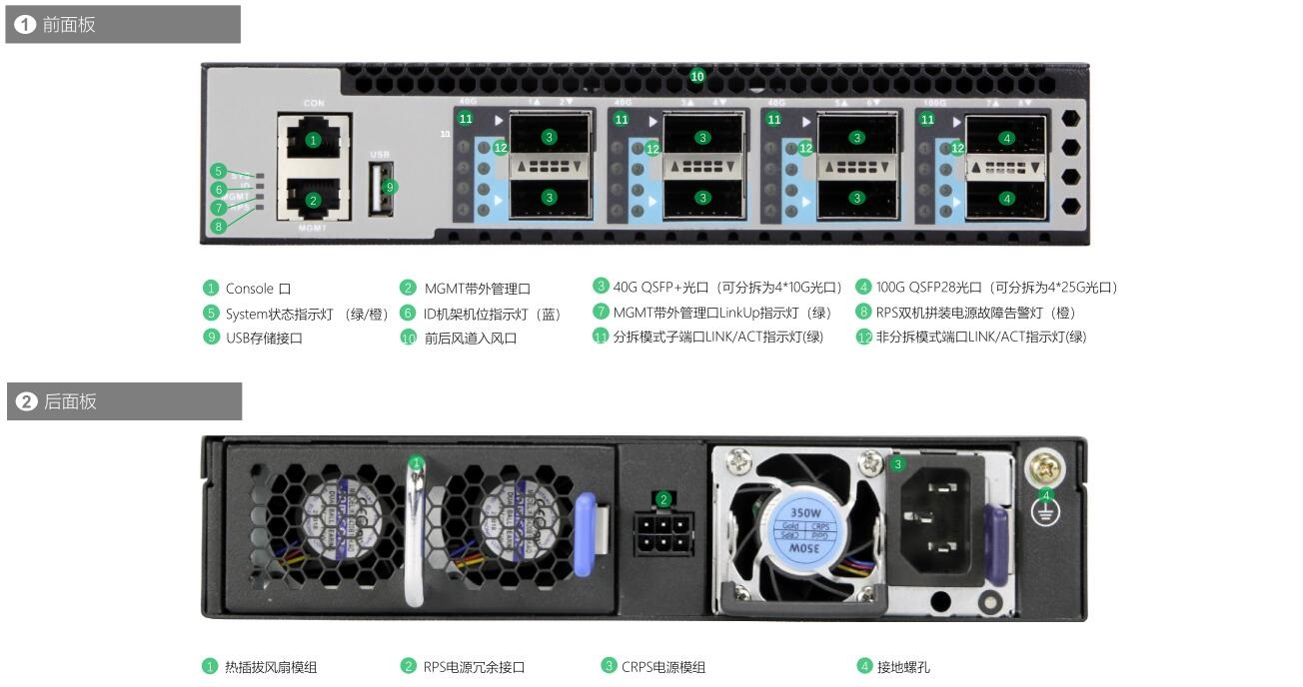
- 产品特点
- 采用运营商级、高性能以太网核心交换芯片
交换机采用国产自研高性能以太网核心交换芯片，可满足城域网、企业网、数据中心、超融合等应用的需求。
- 弹性端口形态、内置配置模板、清晰的端口状态指示
原生40G/100G端口形态，通过端口分拆可支持10G/25G模式。分拆后的逻辑端口有独立的端口状态指示灯，可清晰显示每个拆分端口的收发包工作状态方便运维。预制多种配置模板，一键切换端口模式：6*40G+2*100G/24*10G+2*100G/24*10G+8*25G/32*10G；
- 绿色节能的系统设计
采用智能的风扇调速方案，支持实时功耗检测，为客户降低运维成本，打造绿色节能网络。
- 可灵活配置的转发表项满足不同业务部署场景
灵活的表项管理技术FTM，支持根据不同的应用场景需求，调整各类硬件转发表项的大小。
- 高可靠性
现场可插拔模块化电源，支持对芯片组的温度、电源与风扇的状态进行实时监控。
支持MLAG/LACP/VRRP/STP/RSTP/MSTP/Smart Link/BFD/ERPS等特性，全面且高效的保护网络中的数据流量。
- 三网合一服务支持与带宽保证的高品质应用
三网合一服务（IPTV，视频监控等）提供了高带宽。内置的QoS功能和灵活的队列技术可保障高品质的服务。
丰富的组播协议集（IGMP snooping/IGMP v1/v2/v3），支持2K组播组，每组4K逻辑复制，完美支持IPTV业务，有效控制组播时延。
- 全面的网络安全策略
支持用户级、交换机级和网络级的安全控制。
基本的IPv4 / IPv6 / MAC ACL可以分别过滤IPv4 / IPv6/报文，并且，额外提供扩展的IPv4 / IPv6 ACL可以在一个规则内同时匹配报文的二、三、四层信息。以上ACL均可以应用到物理端口、VLAN、端口组和VLAN组上，端口组或VLAN组内的成员共享一套ACL规则，可以节省TCAM资源。
ARP检测和IP源防护功能，防止网络遭受恶意ARP攻击。 提供CPU流量保护、风暴控制功能，优化CPU负载功能。集中式的802.1x认证，禁止非法用户访问网络。
- 出色的管理特性
支持丰富的管理接口，包括Console、带内网口和带外网口、USB口；支持SNMPv1/v2/v3，支持CLI命令行，Web网管，TELNET及FTP配置使设备管理更方便，并且支持SSH2.0、SSL等加密方式，使得管理更加安全。

- 产品规格
项目 | S9500-6QF-2HQF
固定端口 | 6*40GE QSFP+端口，  2*100G QSFP28端口
管理端口 | 1个Console口、1个带外网管口、1个USB
交换容量 | 3.6Tbps
包转发率 | 1480Mpps
工作温度 | -10~50°C
存储温度 | -20~70°C
工作湿度 | 10%～90%无凝结
存储湿度 | 5%～95%无凝结
外观尺寸 | 355(L)×215(W)×44(H)mm
整机重量 | <3.3Kg
防雷等级 | 6KV
输入电压 | AC：90～264V/50～60Hz
整机功耗 | <350W
- 业务特性
Feature |  |  | Description
Type | Sub Type | Feature | Description
Ethernet basic features | Ethernet | interface | Ethernet interface operating modes(full duplex, half duplex, and auto)
Ethernet basic features | Ethernet | interface | negotiation)
Ethernet basic features | Ethernet | interface | Ethernet interface operating rates
Ethernet basic features | Ethernet | interface | Jumbo Frame
Ethernet basic features | Ethernet | interface | port-xconnect
Ethernet basic features | Ethernet | Flow-control | Flow-control tx/rx
Ethernet basic features | Ethernet | storm-control | Port based storm-control
Ethernet basic features | Ethernet | Port-block | Port-block(know-unicast/unknow-unicast/know-multicast/unknow-
Ethernet basic features | Ethernet | Port-block | multicast/broadcast)
Ethernet basic features | Ethernet | Port-isolate | L2/L3/All Port-isolate
Ethernet basic features | Ethernet | Port-isolate | Uni-direction isolate
Ethernet basic features | Ethernet | L2 Protocol Tunnel | L2 Protocol Tunnel(support CDP/CFM/DOT1X/LLDP/SLOW-PROTO/STP/VTP
Ethernet basic features | Ethernet | Forward mode | Store-and-forward
Ethernet basic features | Ethernet | Forward mode | Cut-through
Ethernet basic features | VLAN | VLAN Access mode | Access/Trunk
Ethernet basic features | VLAN | VLAN Access mode | Default VLAN
Ethernet basic features | VLAN | VLAN Classification | VLAN Classification(port based/mac based/ip based/protocal based)
Ethernet basic features | VLAN | QinQ | Basic QinQ
Ethernet basic features | VLAN | QinQ | Selective QinQ
Ethernet basic features | VLAN | QinQ | VLAN Mapping（1:1 VLAN Translation）
Ethernet basic features | VLAN | VLAN Statistics | VLAN Statistics
Ethernet basic features | VLAN | Private VLAN | Private VLAN
Ethernet basic features | VLAN | Voice VLAN | Voice VLAN
Ethernet basic features | VLAN | Guest VLAN | Guest VLAN
Ethernet basic features | MAC | MAC Address Table | Automatic learning and aging of MAC addresses
Ethernet basic features | MAC | MAC Address Table | Hardware Learning
Ethernet basic features | MAC | MAC Address Table | Static and dynamic MAC address entries
Ethernet basic features | MAC | MAC Address Table | blackhole MAC
Ethernet basic features | MAC | MAC Flapping detect | MAC Flapping detect
Ethernet basic features | MAC | Port Bridge | Port Bridge
Ethernet basic features | LAG | Link aggregation | Static-LAG & LACP
Ethernet basic features | LAG | Link aggregation | LAG load balance（SLB）
Ethernet basic features | LAG | Link aggregation | LAG load balance（DLB）
Ethernet basic features | LAG | Link aggregation | LAG load balance（RR）
Ethernet basic features | LAG | Link aggregation | LAG Self-healing
Ethernet basic features | LAG | Link aggregation | Link aggregation weighting
Ethernet Ring protection features | xSTP | STP | Spanning-Tree Protocol
Ethernet Ring protection features | xSTP | RSTP | Rapid Spanning-Tree Protocol
Ethernet Ring protection features | xSTP | MSTP | Multi-instance Spanning-Tree Protocol
Ethernet Ring protection features | xSTP | Spanning-Tree Protocol Protection | BPDU Filter/Guard
Ethernet Ring protection features | xSTP | Spanning-Tree Protocol Protection | Root Guard
Ethernet Ring protection features | xSTP | Spanning-Tree Protocol Protection | Loop Guard
Ethernet Ring protection features | xSTP | Spanning-Tree Protocol Protection | Anti TC-BPDU attack
Ethernet Ring protection features | ERPS | ERPS | Single ERPS ring
Ethernet Ring protection features | ERPS | ERPS | tangent ERPS rings
Ethernet Ring protection features | ERPS | ERPS | intersecting ERPS rings
Ethernet Ring protection features | ERPS | ERPS | compatible with RRPP
Ethernet Ring protection features | Loopback Detect | Loopback Detect | Loopback-detection
Layer2 Multicast | Layer2 Multicast | IGMP Snooping | IGMPv1/v2/v3 Snooping
Layer2 Multicast | Layer2 Multicast | IGMP Snooping | Fast leave
Layer2 Multicast | Layer2 Multicast | IGMP Snooping | Static IGMP snooping group
Layer2 Multicast | Layer2 Multicast | MVR | MVR（Multicast VLAN Registration）
IPv4 Forwarding | ARP | ARP | Static and dynamic ARP entries
IPv4 Forwarding | ARP | ARP | Aging of ARP entries
IPv4 Forwarding | ARP | ARP | Gratuitous ARP
IPv4 Forwarding | ARP | ARP proxy | basic ARP-Proxy
IPv4 Forwarding | ARP | ARP proxy | local ARP-Proxy
IPv4 Forwarding | IPv4 Unicast Routing | IPv4 Static Routes | IPv4 Static Routes
IPv4 Forwarding | IPv4 Unicast Routing | IPv4 Static Routes | blackhole Routes
IPv4 Forwarding | IPv4 Unicast Routing | IPv4 Static Routes | co-work with IP SLA
IPv4 Forwarding | IPv4 Unicast Routing | IPv4 Static Routes | VRF（Virtual Routing and Forwarding）
IPv4 Forwarding | IPv4 Unicast Routing | IPv4 Static Routes | uRPF check
IPv4 Forwarding | IPv4 Unicast Routing | RIP | RIPv1/v2
IPv4 Forwarding | IPv4 Unicast Routing | Route policy | Route-map
IPv4 Forwarding | IPv4 Unicast Routing | Route policy | IPv4 prefix-list
IPv4 Forwarding | IPv4 Unicast Routing | PBR | PBR（Policy-based Routing）
IPv4 Forwarding | IPv4 Unicast Routing | ICMP | ICMP redirect
IPv4 Forwarding | IPv4 Unicast Routing | ICMP | ICMP unreachables
IPv4 Forwarding | IPv4 Unicast Routing | ECMP | ECMP(SLB)
IPv4 Forwarding | IPv4 Unicast Routing | ECMP | ECMP(DLB)
IPv4 Forwarding | IPv4 Unicast Routing | ECMP | ECMP(RR)
IPv4 Forwarding | IPv4 Unicast Routing | ECMP | ECMP Self-healing
IPv4 Forwarding | IPv4 Unicast Routing | ip unnumbered | ip unnumbered
IPv4 Forwarding | IPv4 Multicast Routing | IGMP | IGMPv1/v2/v3
IPv4 Forwarding | IPv4 Multicast Routing | IGMP | IGMP-Proxy
IPv4 Forwarding | IPv4 Multicast Routing | IGMP | IGMP SSM Mapping
IPv4 Forwarding | IPv4 Multicast Routing | VRRP v3 | VRRP v3
IPv4 Forwarding | VRRP | VRRP | VRRP
IPv4 Forwarding | VRRP | VRRP | Track for VRRP
 | Smart Link | Smart Link | multi-instance
 | Smart Link | Smart Link | load balance
 | Smart Link | Smart Link | Multi-Link
 | Smart Link | Smart Link | Monitor-link
 | MLAG | MLAG | MLAG basic
 | MLAG | MLAG | MLAG orphan Port
QoS features | QoS | Traffic classification | Traffic classification based on COS/DSCP (simple classification)
QoS features | QoS | Traffic classification | Traffic classification based on ACL ( complex classification)
QoS features | QoS | Traffic classification | Traffic classification based on inner header of the tunnel packets
QoS features | QoS | Traffic behaviors | Queue scheduling
QoS features | QoS | Traffic behaviors | Remark the priority fields(COS/DSCP) of the packet based on ACL
QoS features | QoS | Traffic behaviors | Remark the priority fields(COS/DSCP) of the packet based on Table Map
QoS features | QoS | Traffic behaviors | Flow redirection
QoS features | QoS | Traffic behaviors | Flow mirror
QoS features | QoS | Traffic policing | Traffic policing based on direction(in/out) of Port
QoS features | QoS | Traffic policing | Traffic policing based on direction(in/out) of VLAN
QoS features | QoS | Traffic policing | Traffic policing based on direction(in/out) of flow
QoS features | QoS | Traffic policing | Traffic policing based on direction(in/out) of aggregated flow
QoS features | QoS | Traffic shaping | Queue based traffic shaping
QoS features | QoS | Traffic shaping | Port based traffic shaping
QoS features | QoS | Congestion management | SP（Strict Priority）scheduling
QoS features | QoS | Congestion management | WDRR（Weighted Deficit Round Robin）scheduling
QoS features | QoS | Congestion management | SP + WDRR mixed scheduling
QoS features | QoS | Congestion avoidance | TD（Tail Drop）
QoS features | QoS | Congestion avoidance | WRED（Weighted Random Early Detection）
QoS features | QoS | Traffic statistics | Packet counts and bytes statistics based on traffic classification
QoS features | QoS | Traffic statistics | Packet counts and bytes statistics based on the color after traffic policing
QoS features | QoS | Traffic statistics | Forwarded and discarded packet counts and bytes statistics
Data Center | VARP | Virtual gateway | VARP（Virtual-ARP）
Data Center | VARP | Virtual gateway | VARP subnet
Security and management | System Security | SSH | SSHv1/v2
Security and management | System Security | SSH | RSA Key generation
Security and management | System Security | RADIUS | RADIUS
Security and management | System Security | TACAS+ | TACAS+
Security and management | System Security | AAA | Authentication
Security and management | System Security | AAA | Authorization
Security and management | System Security | AAA | Accounting
Security and management | System Security | Dot1x | Port based dot1x
Security and management | System Security | Dot1x | MAC based dot1x
Security and management | System Security | Dot1x | Guest VLAN
Security and management | System Security | ACL | MAC/IP ACL
Security and management | System Security | ACL | Basic Mode ACL
Security and management | System Security | ACL | Port-group ACL
Security and management | System Security | ACL | VLAN-group ACL
Security and management | System Security | ACL | IPv6 ACL
Security and management | System Security | ACL | ACL UDF
Security and management | System Security | ACL | Global ACL
Security and management | System Security | ACL | Time Range
Security and management | System Security | ARP Inspection | ARP Inspection
Security and management | System Security | IP Source Guard | IP Source Guard
Security and management | System Security | Port Security | Limitation on MAC address learning on interface
Security and management | System Security | VLAN Security | Limitation on MAC address learning on VLAN
Security and management | System Security | Control Plane Policy (COPP) | Black list/wihte list
Security and management | System Security | Control Plane Policy (COPP) | Rate limit
Security and management | System Security | CPU Traffic Limit | CPU Traffic Limit
Security and management | System Security | Prevent DDOS attack | Prevent DDOS attack (ICMP Flood/Smurf/Fraggle/LAND/SYN Flood)
Security and management | System Security | Login filter | Telnet/SSH ACL filtering
Security and management | System Security | Login filter | Telnet/SSH IPv6 ACL filtering
Security and management | System Security | Link-Flapping detection | Link-Flapping detection
Security and management | Network Management | DHCP | DHCP Server
Security and management | Network Management | DHCP | DHCP Relay
Security and management | Network Management | DHCP | DHCP Snooping
Security and management | Network Management | DHCP | DHCP Client
Security and management | Network Management | DHCP | DHCP Option82
Security and management | Network Management | DHCP | DHCP Option252
Security and management | Network Management | RMON | RMON
Security and management | Network Management | sFlow | sFlow v4/v5
Security and management | Network Management | IP SLA | IP SLA
Security and management | Network Management | EFD | Elephant Flow Detection
Security and management | Network Management | NTP | NTP（Network Time Protocol）
Security and management | Network Management | Errdisable | Errdisable detection and recovery
Security and management | Network Management | DNS | Static DNS Client
Security and management | Network Management | LLDP | LLDP
Management | Terminal Services | Command Line Interface | Configurations through CLI (Command Line Interface)
Management | Terminal Services | Help information | Banner configuration
Management | Terminal Services | Help information | Help information in English
Management | Terminal Services | Terminal service | Vty Terminal service
Management | Terminal Services | Terminal service | Console Terminal service
Management | Management Port | Management interface | Inband management interface and configuration
Management | Management Port | Management interface | Outband management interface and configuration
Management | Management Port | User privilege management | Privileged user proirity and privileged commands
Configuration and maintenance | Configuration Management | SNMP | Network management based on SNMPv1/v2c/v3
Configuration and maintenance | Configuration Management | SNMP | Public and private MIB
Configuration and maintenance | Configuration Management | SNMP | Public and private Trap
Configuration and maintenance | Configuration Management | WEB | Configuration and management based on WEB UI
Configuration and maintenance | Configuration Management | RPC-API | Configuration and management based on RPC-API
Configuration and maintenance | Configuration Management | SmartConfig | SmartConfig（Automatically configuration when system start）
Configuration and maintenance | Configuration Management | OVSDB | Configuration and management based on OVSDB
Configuration and maintenance | Configuration Management | system profile configuration | change the system specifications by choose different STM Profiles
Configuration and maintenance | Configuration Management | License control | Feature configuration based on License
Configuration and maintenance | Configuration Management | Restore factory default | Restore factory default configuration
Configuration and maintenance | Configuration Management | configuration | Restore factory default configuration
Configuration and maintenance | File System | File system | File system(support directory and file management)
Configuration and maintenance | File System | Upload and download | Upload and download files through FTP or TFTP
Configuration and maintenance | File System | Upload and download | Upload and download files through Xmodem
Configuration and maintenance | Debugging And Maintenance | Debug | per-module Debug features
Configuration and maintenance | Debugging And Maintenance | Debug | ICMP Debug
Configuration and maintenance | Debugging And Maintenance | BHM | Software process monitor: BHM（Beat Heart Monitor）
Configuration and maintenance | Debugging And Maintenance | BHM | Hardware Watch Dog
Configuration and maintenance | Debugging And Maintenance | Log & alarm | CPU usage display and alarm
Configuration and maintenance | Debugging And Maintenance | Log & alarm | Memory usage display and alarm
Configuration and maintenance | Debugging And Maintenance | Log & alarm | Device temperature、PSU、FAN、status display and alarm
Configuration and maintenance | Debugging And Maintenance | Log & alarm | User operation logs
Configuration and maintenance | Debugging And Maintenance | Log & alarm | Management of logs, alarms, and debugging information
Configuration and maintenance | Debugging And Maintenance | VCT | VCT（Virtual Cable Test）
Configuration and maintenance | Debugging And Maintenance | system diagnostics | Detailed Diagnostic-information collection
Configuration and maintenance | Debugging And Maintenance | Reboot | Manual reboot
Configuration and maintenance | Debugging And Maintenance | Reboot | Schedule Reboot
Configuration and maintenance | Debugging And Maintenance | Reboot | Reboot Information logging
Configuration and maintenance | Debugging And Maintenance | network diagnostics | Ping
Configuration and maintenance | Debugging And Maintenance | network diagnostics | IPv6 Ping
Configuration and maintenance | Debugging And Maintenance | network diagnostics | Traceroute
Configuration and maintenance | Debugging And Maintenance | mirror | Port mirror
Configuration and maintenance | Debugging And Maintenance | mirror | Flow mirror
Configuration and maintenance | Debugging And Maintenance | mirror | Remote mirror
Configuration and maintenance | Debugging And Maintenance | mirror | Multi-destination mirror（m:n）
Configuration and maintenance | Debugging And Maintenance | mirror | Use CPU as mirror source
Configuration and maintenance | Debugging And Maintenance | mirror | Use CPU as mirror destination and analyze packet
Configuration and maintenance | Debugging And Maintenance | mirror | ERSPAN
Configuration and maintenance | Debugging And Maintenance | CPU statistics | To CPU/From CPU packets statistics
Configuration and maintenance | Debugging And Maintenance | L2 Ping | layer2 network connectivity detection - L2Ping (MAC Ping/Trace)
Configuration and maintenance | Debugging And Maintenance | UDLD | UDLD（Unidirectional Link Detection）
Configuration and maintenance | Debugging And Maintenance | unidirectional | unidirectional forwarding of the fiber
Configuration and maintenance | Debugging And Maintenance | Loopback | port loopback
Configuration and maintenance | Debugging And Maintenance | Loopback | hardware loopback（internal/external）
Configuration and maintenance | Debugging And Maintenance | System time | Time configuration
Configuration and maintenance | Debugging And Maintenance | System time | Timezone
- 订购信息
设备名称 | 设备信息
S9500-6QF-2HQF | 6个40G QSFP端口，2个100G QSFP28端口；
模块 | 模块信息
QSFP+-40G-SR4-MM850 | 40G QSFP模块 SR4多模模块，MPO接口，波长850nm，传输距离100m
QSFP28-100G-SR4-MM850 | 100G QSFP28模块 SR4多模双芯，MPO接口，波长850nm，传输距离100m
- 联系我们
 | 深圳市万网博通科技有限公司  电话：0755-61133269  400 ：400-088-7500  网址：http://www.tg-net.cn  公司地址：深圳市龙华区大浪街道新石社区浪荣路17号3层

关于文档
本文档中的商标、图片、标识均归深圳市万网博通科技有限公司所有。
本文档可能含有预测信息，因此本文档信息仅供参考，不构成任何要约或承诺，本公司做出更正或修改恕不另行通知。
版权所有 © 深圳市万网博通科技有限公司 保留一切权利
V202309

